VLSI Project Block Diagram

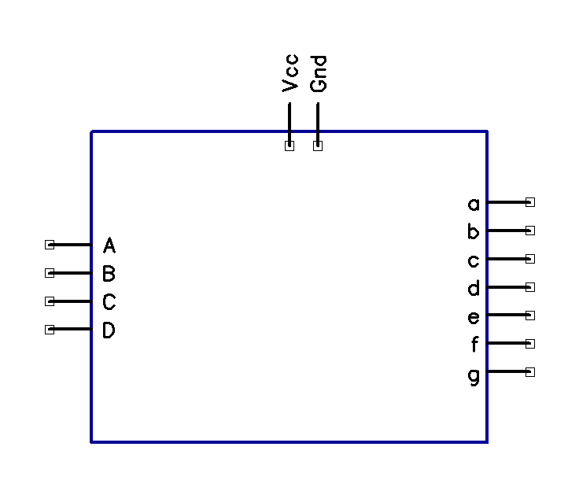

The project is a 7 segment display driver. Inputs A,B,C, and D are the binary input from an external device. A represents the least significant bit, and D is the most significant bit. The outputs attach to the cathodes of a 7 segment display, an example of the connections is given below:

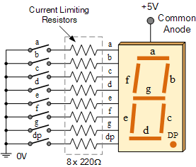

(Image from http://www.electronics-tutorials.ws/blog/7-segment-display-tutorial.html)

When a binary number is provided on the input pins, the IC will drive low the appropriate outputs to illuminate the desired number on the 7 segment display.